FM116 (211) W
Spring 2015
04/15/2015
Team Project Paper
Group C

Table of Contents:
INSTAGLAM
Page 1: Cover Page
Page 2: Table of Contents
Page 3: Players for Each Function
Page 4: Our Missions and Goals
Page 5: Our Ownership
Page 6: Our Policies
Page 7: Employee Motivation
Page 8: Our Service and Target Market Page 9: Marketing Mix
Page 10-11: Social Media
Page 11-12: Swot Analysis
Page 12-13: Long Term Planning
Page13-14: Obtain Capital
Page 14: Stock
Page 15-19: Financial Statements
Page20-21: Financial Report
Page 22: New Product Development
Page 23: Bibliography

Members of InstaGlam

CEO: Alexxis Danica
CFO: Erika Desroches
Marketing Director: Brianna Conte
COO: Hari Kim

Our Mission

Our Mission is to create an effortless and efficient experience for shoppers through our online service. The only thing we require of our shoppers is to take a survey upon signing up for our services. The survey entails questions about the shopper’s personal style, interests, lifestyle, budget, and more. The results of the survey allow for us to establish a curated wardrobe for the shopper, with pieces from the retailers in which we contract deals with; Therefore, providing our shopper with a wardrobe that reflects his or her style for a great price. Depending on what package our customers select, we will send a shipment of clothing to our customer each month in order to keep his or her wardrobe up to date, and relevant to his or her lifestyle.
Our Goal and Strategy
Our goal is to build strong relationships with less prominent retailers in order to establish ourselves in the business, and raise awareness for our counterparts at the same time. Once we have a bit of a following, we would like to explore some of the bigger name retailers in the business, and work with them to provide the best deals for our clients, while providing them with new and upcoming trends. Ultimately, we would like InstantGLAM to revolutionize the fashion industry, and grant every shopper a very personal, effortless, succinct and affordable experience.

Our Ownership

Our company, Instant GLAM, is dedicated to our fashion loving customers and employees. Instant GLAM is going to be a privately owned corporation, bringing in as much profit as we can. All profits made will be spent as we please, keeping as much as we would like for ourselves, and using as much as we would like for our company’s growth. We do not have to produce annual finance reports explaining our finances. We believe a privately owned corporation is the key to our company being as successful as possible. As a privately held company, we have complete authority over operational decisions and we do not have to worry about shareholder expectations and interference. Instant GLAM has an unlimited life, expected to outlive its original owners, but can be easily transferred to a different owner if needed. Instant GLAM will truly thrive as a privately owned corporation because we have the right dedicated employees to help us do so.

Our Policies

Here at Instant GLAM, our clients are the foundation of our business and their contentment is the key to our success. In order to fully take advantage of all the benefits provided by Instant GLAM, you must register for an account. Registration is easy, and completely free. All that is required is that you take our style survey, create a username, and create a password to register. Once registered, you will be able view a customized selection of shoes, tops and bottoms. You may not make a purchase from us until signing up for one of the four plans we have in place. Upon selecting a package, you can order any outfit(s) from the customized selection we have created for you, and it will be shipped to you after your credit card payment is successfully processed. Your personal collection may change every month so that it stays current. Subsequently, Instant GLAM cannot warrant that a selection available in a particular month will be available the following month. If you receive an unwanted purchase, or if your purchase is not completely to your satisfaction, you may return it at our expense and we will credit your account. Simply visit our website and login to your account to print your pre-paid shipping label, and drop your package off at the shipping provider location. Please be sure to include your packing slip when returning any product. You will receive full store credit to your account. We will not accept any items that have been worn or items without tags. You may cancel your account at any time by contacting customer service during hours of operation.
Employee Motivation

Our company InstaGLAM has great consideration for our employees and wants to ensure their happiness and satisfaction in working for us. There are many things we plan on doing to make them feel comfortable, boost their morale, and encourage productivity. The first is to create friendly and open working environment. Since our service only requires online networking and planning for customers we have a station where it’s all about thinking, creating, and planning. In order for our employees to do their best we believe in creating a space they are able to. This means no tight grey cubicles. But, instead a lovely, open think tank. A work environment that’s open, fun, and unique to spark creativity and motivate employees in attracting more customers on a daily basis. In addition to this, our dress code will be less strict than the average company. Since our focus is fashion for every kind of person, employees will be encouraged to express themselves at work in whatever they find fashion forward. Of course there will be rules against the extremes: offensive/inappropriate pictures/works, nudity, an extreme amount of inappropriate skin. It is still a work place, but a creative and free one. Lastly, we will hold many social events to let out employees to get to know each other well outside of work, so that the bonds in the workplace are even stronger. This can include holiday parties, get together, and workshops. We want to do whatever we can to motivate and keep our employees happy. Happy employees=good ideas=happy customers=success in the business.

Our Service

InstaGLAM is an online service intended to provide a very brief yet personal shopping experience. All that we require of our customer is to fill out a style survey in order for us to generate a customized selection of shoes, tops and bottoms from the retailers in which we are contracted. We continually update customized selections as more inventories become available. Conveniently, all transactions can be made directly through www.instaGLAM.com.
Target Market

Our company Instant Glam thinks of each potential female buyer as an individual and focuses on her needs. As a company we wish to target the career-oriented women who may not necessarily have the time to shop, whether it be at the mall or online. More specifically, we want to focus on women who are little fashion inept, typically between the ages of 16-45. In a society where the end goal is to create products and services to make our lives easy and efficient, InstaGlam wishes to target and serve those customers who have a difficult time with shopping and provide an exciting shopping experience at the push of a few buttons. We recognize that every client is different and our company seeks to satisfy each individual’s needs. Through these methods, we hope to create great relationships with this target group.

Marketing Mix
Product | - A service to provide a virtual personal stylist and shopper.  - A curated collection of bridge, moderate, and fast fashion retailers.  - Supports an up-to-date wardrobe that reflects the clients personal style.
Price | - Free Registration and Style Consultation.  - Monthly/Annual Fee starting at $55/month.  - Package #1 – Includes one outfit (1 top, 1 bottom, and 1 pair of shoes) per month at $55/month.  - Package#2 – Includes 4 outfits (4 tops, 3 bottoms, and 2 pairs of shoes) per month at $200/month.  - Package#3- Includes 4 outfits (4 tops, 3 bottoms, and 2 pairs of shoes) per month at $2100/year and free shipping on all purchases.  - VIP Package- Includes 6 Outfits (6 tops, 4 bottoms and 2 pairs of shoes) per month, free shipping, and exclusive promotions for $3300/year.
Place | www.instantglamfashion.com
Promotion | - Free matching tote bag with monthly outfit(s).  - Promotional deals that vary by membership status.

Social Media

We are in an environment where social media is what keeps us going. From makeup, to fashion, that is how we all network and keep up with the current trends. It is essential for a modern, trendy business to keep up to date with the latest social media. Through our research we have determined that Instagram is the most effective and paid attention social media of our main, most receptive target market, fashion forward girls. Many fashion forward businesses are choosing to use social media to their advantage. Our Instagram account is @InstaGLAM and will be used for many different things. It will create a direct connection between the customer and the company. We will follow the customer’s that follow us which allows the customer to feel like we care, which we do. Our posts will include many things. Firstly, our Instagram will feature customers who have purchased apparel from our site sporting their news outfits. The caption will include their review/opinion/comments on their new clothes/accessories and then an additional comment from us to them! This way the customer feels special for being featured which creates a bond that can lead to loyalty and return use. It can also show others example of outfits that have been purchased and shows proof of a happy customer. This will encourage people who are skeptical to go ahead and make purchases with us! In addition to featuring customers we will post fashion tips. These tips will give helpful, fashion related advice to our followers. Lastly, the Instagram account will be used to give our followers special promos. We can use this to give people who follow us coupons and discounts which encourages them to continue following us so they can see the other things we have to offer. For example, on New Year’s we posted a promo code that let customers who typed the code “holiday” in while making a purchase on New Year’s gets 10% off their orders. People who weren't following wouldn’t know about the promotion and will miss out. This will also encourage people to make purchases they have been skeptical on that day. Overall our social media account will help us gain more customers and allow for them to be trendy and up to date with what’s in right now.

Swot Analysis

Strengths / Weaknesses are Internal
- Provides updated fashion news and style advising.
- Features diverse array of brands.
- Features several of product categories, including women’s clothing, accessories, and footwear.
- Displays merchandise on our website that appeal to customers.
- Interacts with customers through social media platforms including Face book and Instagram.
- Professional and passionate employees that ensure the brand is continuously innovating and growing.
- User friendly website. Customers can easily browse all the latest fashion trends on the homepage or search for a particular style or category they may be interested in.

Weakness
- As an online only platform, customers do not have the option of trying on or feeling the clothing prior to purchase.
- Instead of traditional media, only online advertising is getting customers away of our company
- The sources of income are from advertising and commission fee only.
- Monthly fee of clothing

Opportunities / Threats are External

- Not just buying single item, the consumers are in packages which encourages them to buy more products.
- Competitors only provide a selected and limited number of brands while our company has a wide variety of different brands and styles that will satisfy each customer.
- The e-commerce market is continuously growing.
- Globalization is expanding the reach of retailers, as we are able to connect with consumers around the globe and grow our business into a bigger company.

Threats

- Many retailers are entering the market, featuring only e commerce platforms to sell their merchandise.
- Many retailers feature an ecommerce website in addition to their brick and mortar stores, giving the consumers the option of how to shop as well as the ability to see and try on their products before their purchase.
- Some online retailers are providing more services as the additional values to the consumers.

Long Term Planning

Instant GLAM has a bright future ahead. Speaking in terms of the next 5 years, we plan to expand Instant GLAM to become small shops around the world and eventually overseas, where people can come get analyzed by our fashion advisors in person, and have personal outfits picked out, and a chance to see what Instant GLAM is about in person. This will result in jobs for people all over the world, both in our offices but now also in our stores; this will also be great for people who enjoy one on ones, and for those who enjoy a personal experience rather than just an online experience. In the next 7 years we hope to expand our stores by adding in not only more personal stylists, but also cosmetic people, so our stores can become a place where customers will come to not only get analyzed, a new outfit, and sign up for our monthly program, but where they can come get ready for a night out or just to be glammed up to feel better about themselves, after we are Instant GLAM. Customers who enjoy our personal experiences will be given the option every month to either get their online styles shipped to them or they can come into our stores and continue to have that one on one experience. By 10 years, Instant GLAM hopes to be known around the world, and be trusted to make our customers as fabulous as they deserve to be. Our online community will expand to being able to choose your own personal stylist and cosmetic team to come to your house, dress you, do your hair, makeup and nails for a special night out. Not only will we be able to offer monthly packages to our committed customers, but now Instant GLAM can be your new go-to glam squad. We hope to be everything and more to our loyal customers, providing the best customer experiences, and being known around the world as your number one Instant GLAM.

Obtain Capital

Our company plans on obtaining capital through business loans. Since our company is based mostly online, it is not necessary for us to have an enormous start up budget because we have eliminated any in store costs. In turn, these removed costs will help us to save money and invest that capital into another part of the company. This allows us to opt out of selling our companies stocks for the moment, and focus on creating a positive brand image first. We do not need to purchase property for stores, just simply office space and some small storage space if necessary. We will rely on bank loans and our personal assets to grant us greater financial freedom. Business loans will help to increase our working capital, help us to maintain our operating cash flow, and therefore, make it easier for us to cover any unexpected expenses. We will be able to make payments on our loans more easily by using the new income gained from expanding our business.
Stock
Although stock is an appealing option for our company, we have decided to wait a year in order to determine our growth before selling a larger amount of shares on the market. During this gap year, we will be continuously watching the stock to see how companies similar to ours, do in the market. We do not want to take a risk of losing money towards a part of our company that might not be profitable. As a company we do want to grow, but we do not want to take on more than we can afford. If we invest in larger stocks there is a risk at hand. For instance, if the stock we invest in fails, recovery for the company, as a whole, will be a long-term process. At that moment what is best for our company is to partially rely on outlier loans and investments from others and study how our limited shares will do in the market. Our company values the importance of experience, therefore we shall see how similar stocks and our limited ones will react to the market before increasing the amount of shares we have currently. If the stocks do not show positive results, we could potentially pull out of the market, or work towards making our company shares profitable.

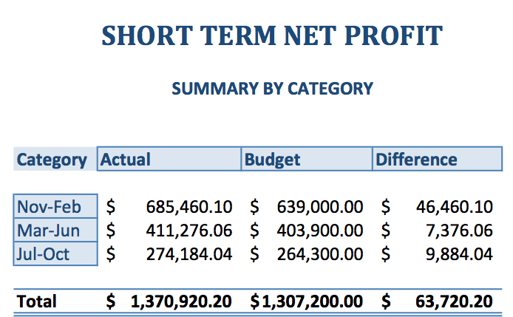

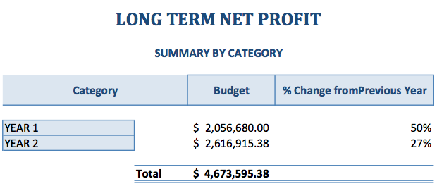
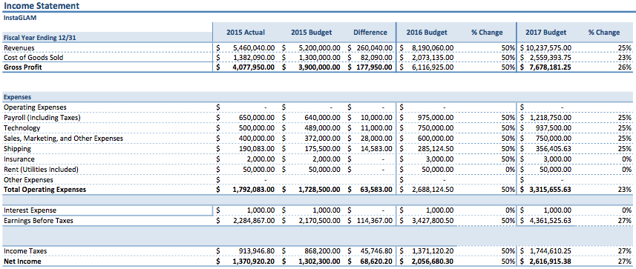
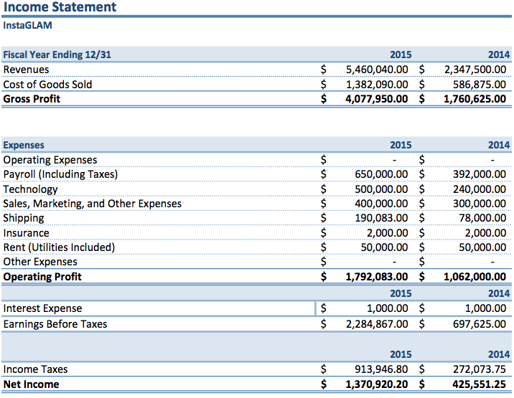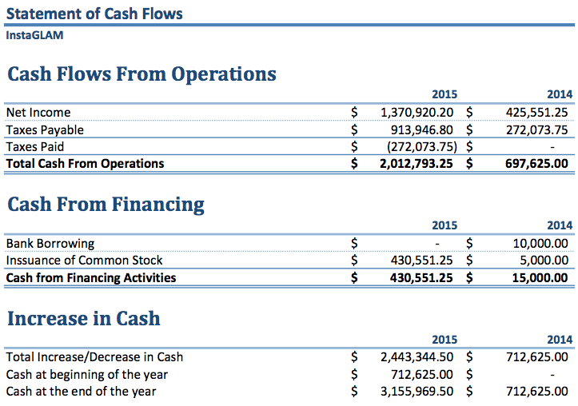
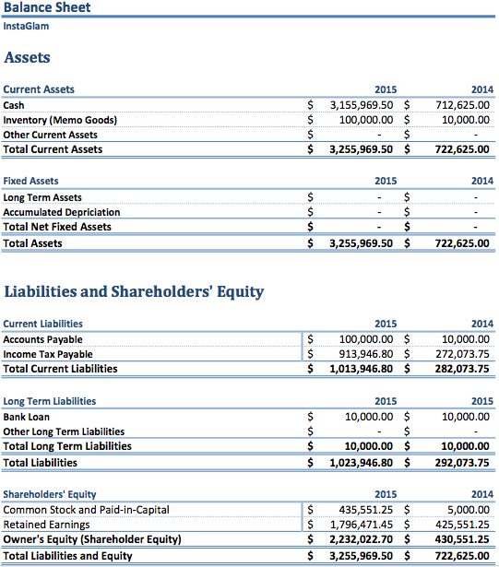

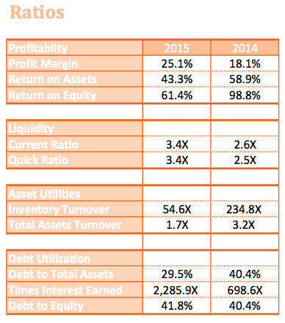

Financial Report
After reviewing the numbers, and analyzing the financial statements, it can be said that InstaGlAM had a fantastic year despite having decreased profitability and asset utilization ratios. In terms of profitability ratios, we saw a 7% increase in profit margin and a ratio of 25.1%. This percentage indicates that for each dollar in sales, in the year 2015, InstaGlam makes a profit of $0.25. The return on assets (ROA), this year was 43.3%, meaning that there is a return of $0.43 for every dollar invested in assets. This percentage is down 15.6% from 2014. The return on equity was 61.4% this year, a 37.4% decrease from 2014. This percentage denotes that for every $1 invested by the business owners, there is a return of $0.64 used to finance assets.
As for the liquidity ratios used to measure a company’s ability to pay off short-term debt obligations, InstaGLAM saw an increase in both current and quick ratios from 2014. The current ratio for this year was 3.4, an increase of 0.8 from 2014. This number indicates that for every dollar of current liabilities, the company has $3.40 of current assets to pay off current liabilities. Similar to the current ratio, the quick ratio measures how well the company can meet its current obligations without relying on the sale of inventories. InstaGLAM’s quick ratio for 2015 was 3.4, a 0.9 increase from 2014.
In order to determine how well our assets are working to generate sales we used asset utilization ratios. In using the inventory turnover ratio, we calculated that InstaGLAM replaced its inventory 54.6 times this year. While this number is a sharp decrease from last year’s rate of 234.8, we have significantly increased our inventory. In other words, we are still turning over inventory pretty quickly. Concerning InstaGLAM’s total assets turnover, the ratio calculated for 2015 was 1.7, a decrease of 1.5 from last year. This figure reveals that the company generated $1.70 in sales for every $1 in total assets. Lastly, we calculated debt utilization ratios to measure the firm's use of financial leverage and ability to avoid financial distress in the long run. The debt to total assets decreased from 40.4% to 29.5%, meaning that we are at a lower degree of leverage and, therefore at a lower financial risk than last year. The debt to equity ratio was 41.8%, a 1.4% increase from 2014. This percentage represents the proportion of equity and debt InstaGLAM used to finance its debt. Generally speaking, it is better to keep the debt to equity ratio low, as a high ratio can result in unstable earnings due to additional interest expenses. Overall, InstaGLAM had a strong financial showing both internally and across the industry in the year 2015.

New Product Development

Over the next few years we would like to invest in our technology department to implement new products that will make InstaGLAM a more effective business. After 2017, we plan to start cutting back payroll. Ultimately, we want the InstaGLAM staff to be only comprised of the owners and board members; therefore, keeping the cost of payroll to a minimum. Realistically we will have to have employees aside from the owners and board members, but we will keep that number low. In order to get closer to our goal, we would like to create an app built into our website that will allow our clients to submit a full body image of themselves. Upon completing the survey, the app will automatically analyze the users dimensions and determine the best size and style fits available through our database of retailers. The app will also generate a manual with possible outfit combinations based on the clothing we have already sent, and the latest shipment. The image submitted by the client will remain on her profile until she chooses to update the picture.

Bibliography

"Amazon.com Inc." Yahoo! Finance. N.p., n.d. Web. 12 Mar. 2015.

"Clothing E-commerce Site Business Plan." Sample. N.p., n.d. Web. 9 Apr. 2015.

"Course Not Available." N.p., n.d. Web. Feb.-Mar. 2015.

"FabFitFun Launches VIP Box Full of the Best Beauty Swag." Shape Magazine. N.p., n.d. Web. 29 Jan. 2015.
Investopedia - Educating the World about Finance." Investopedia. N.p., n.d. Web. 5 Apr. 2015.
Kokemuller, Neil. "What Are the Advantages & Disadvantages of Selling Stock to Raise Funds for a Small Business?" Chron. N.p., n.d. Web. 1 Apr. 2015.

"Ratios and Formulas in Customer Financial Analysis." Ratios and Formulas in Customer Financial Analysis. N.p., n.d. Web. 9 Apr. 2015.

"Shoedazzle." ShoeDazzle. N.p., n.d. Web. 10 Feb. 2015.
"SWOT Analysis: Examples, Templates & Definition."BusinessNewsDaily.com. N.p., n.d. Web. 1 Apr. 2015.

"Use Our Financial Ratio Analysis Calculator To Help Determine The Health Of Your Business." Financial Ratio Analysis Calculator. N.p., n.d. Web. 3 Apr. 2015.

Alexxis Danica
Brianna Conte
Brianna Conte
"Debt/Equity Ratio Definition | Investopedia." Investopedia. N.p., 23 Nov. 2003. Web. 10 Apr. 2015.
"Liquidity Measurement Ratios: Introduction | Investopedia." Investopedia. N.p., 29 May 2007. Web. 11 Apr. 2015.
Peavler, Rosemary. "Asset Management Ratios and How They Are Used." N.p., n.d. Web. 11 Apr. 2015.
"Debt Management Ratios." Debt Management Ratios. N.p., n.d. Web. 11 Apr. 2015.
Erika Desroches
Erika Desroches

